Prioritizing management goals for stream biological integrity within the developed landscape context

Marcus W. Beck ([marcusb@sccwrp.org](mailto:marcusb@sccwrp.org)), Raphael D. Mazor ([raphaelm@sccwrp.org](mailto:raphaelm@sccwrp.org)), Scott Johnson ([scott@aquaticbioassay.com](mailto:scott@aquaticbioassay.com)), Karin Wisenbaker ([karin@aquaticbioassay.com](mailto:karin@aquaticbioassay.com)), Joshua Westfall ([jwestfall@lacsd.org](mailto:jwestfall@lacsd.org)), Peter R. Ode ([peter.ode@wildlife.ca.gov](mailto:peter.ode@wildlife.ca.gov)), Ryan Hill ([hill.ryan@epa.gov](mailto:hill.ryan@epa.gov)), Chad Loflen ([Chad.Loflen@waterboards.ca.gov](mailto:Chad.Loflen@waterboards.ca.gov)), Martha Sutula ([marthas@sccwrp.org](mailto:marthas@sccwrp.org)), Eric D. Stein ([erics@sccwrp.org](mailto:erics@sccwrp.org))

Version Date: Fri Jul 27 10:58:20 2018 -0700

# Abstract

Stream management goals for biological integrity may be difficult to achieve in developed landscapes where channel modification and other factors impose constraints on in-stream conditions. To evaluate potential constraints on biological integrity, we developed a statewide landscape model for California that estimates ranges of likely scores for a macroinvertebrate-based index that are typical at a site for the observed level of landscape alteration. This context can support prioritization decisions for stream management, like identifying reaches for restoration or enhanced protection based on how observed scores relate to the model expectations. Median scores were accurately predicted by the model for all sites in California with bioassessment data (Pearson correlation r = 0.75 between observed and predicted for calibration data, r = 0.72 for validation). The model also predicted that 15% of streams statewide are unlikely to achieve biological integrity within their present developed landscape, particularly for urban and agricultural areas in the South Coast, Central Valley, and Bay Area regions. We worked with a local stakeholder group from the San Gabriel River watershed (Los Angeles County, California) to evaluate how the statewide model could support local management decisions. To achieve this purpose, we created an interactive application, the Stream Classification and Priority Explorer (SCAPE), that compares observed scores with expectations from the landscape model to assign priorities. We observed model predictions that were consistent with the clear land use gradient from the upper to lower watershed, where potential limits to achieving biological integrity were more common in the heavily urbanized lower watershed. However, most of the sites in the lower watershed scored within their expected ranges, and were therefore given a low priority for restoration. In contrast, two low-scoring sites in the undeveloped upper watershed were prioritized for causal assessment and possible future restoration, whereas three high-scoring sites were prioritized for protection. The availability of geospatial and bioassessment data at the national level suggests that these tools can easily be applied to inform management decisions at other locations where altered landscapes may limit biological integrity.

# Introduction

The widespread use of bioassessment data to assess ecological condition of aquatic environments is a significant advance over chemical or physical methods of assessment, yet managers and stakeholders require contextual information for synthesizing and interpreting biological information. The reference condition concept that is built into many biological indices provides a broad context for observed condition relative to unaltered habitats for a particular region (Reynoldson et al. 1997; Stoddard et al. 2006). However, achieving a reference condition of biological integrity may be challenging if site-specific conditions place limits on spatial and temporal scales that can be effectively managed (Chessman and Royal 2004; Chessman 2014). Use of bioassessment information to guide decisions that affect aquatic resources may also be challenging if the data are not accessible relative to the needs of local stakeholder groups. Accessibility can be limited from a contextual perspective of how likely a site is to achieve biological integrity, but also how bioassessment data collected over multiple locations and times can be used to support decisions or identify priorities. Explicit information is required to not only synthesize site-level bioassessment data at the watershed scale, but also provide an assessment context that is sufficiently interpretable for prioritization.

In developed urban and agricultural landscapes, the majority of stream miles are in poor biotic condition and in need of some level of management (USGS (US Geological Survey) 1999; Finkenbine, Atwater, and Mavinic 2000; Morgan and Cushman 2005). Conventional approaches to protect and restore biological integrity have commonly focused on direct improvements at the site level to mitigate instream stressors (Carline and Walsh 2007; Lester and Boulton 2008; Roni and Beechi 2012; Loflen et al. 2016), whereas upstream preventative measures may be incentivized or enforced through regulation. Although these approaches can lead to improvements in ecological condition, there is no universal remedy for achieving biological integrity in streams. Restoring streams in urban or agricultural settings can be costly and it may be difficult to achieve regional reference-like conditions (Kenney et al. 2012; Shoredits and Clayton 2013). A confounding factor for managing streams in developed landscapes is the extensive modification to streams for flood control or water conveyance. In some cases, channel modification has been proposed as a basis for redefining water quality criteria or for re-evaluating use attainability goals (California Regional Water Quality Control Board, Los Angeles Region 2014). For biological integrity, several states have implemented a tiered aquatic life use or alternative use designations to account for baseline shifts in ecosystem condition from channel modification (e.g, Florida Department of Environmental Protection (2011), US Environmental Protection Agency, Region 10 (2013), Midwest Biodiversity Institute (2016)). Prioritizing among sites that are affected by landscape alteration is a critical challenge for managers in urban and agricultural settings (Walsh et al. 2005; Beechie et al. 2007; Paul et al. 2008).

The application of bioassessment data to inform management requires understanding the effects of multiple stressors acting at local, catchment, or watershed scales (Novotny et al. 2005; Townsend, Uhlmann, and Matthaei 2008; Leps et al. 2015). Nearly half of all stream-miles in the USA are estimated to be in poor biotic condition based on macroinvertebrate bioassesssment index scores and has been associated with in-stream stressors, such as excess phosphorus, nitrogen, or altered physical habitat (USEPA (US Environmental Protection Agency) 2016). These immediate causes of poor biological condition are often linked to landscape-level alterations that occur in the watershed. Consistent and empirical links between land use thresholds and poor biotic integrity have been identified in many cases (Allan, Erickson, and Fay 1997; Wang et al. 1997; Clapcott et al. 2011). Although causal pathways linking land use and degraded biological condition have been described (e.g., Allan (2004), Riseng et al. (2011)), not all pathways of stressors originating from the landscape are clear (e.g., Cormier et al. (2013)). Regardless, land use has long been used as a proxy for environmental condition, and an associative link can be sufficient to predict condition as a function of watershed activities.

Estimating the likely range of biological conditions as a function of historic alteration of the landscape could help prioritize where management actions are most likely to achieve intended outcomes, or conversely, where landscape alteration could limit management success in achieving biological integrity. Here, we define constrained streams as those where reference conditions for the biological community may be difficult to achieve with limited resources because of large-scale, historical impacts from landscape alteration. Anthropogenic stressors that constrain biology may originate from spatial or temporal scales that are difficult to address with most management applications. Understanding limits to biological potential is one approach to identify constraints, and is an important concept in bioassessment that has received some attention. Analysis methods have been explored in a bioassessment context to characterize environmental factors that limit assemblage composition (Chessman, Muschal, and Royal 2008; Chessman 2014). This approach is based on the limiting factor theory that proposes the most limiting biotic or abiotic factor as the primary regulator of species abundance and distribution. Similar concepts have been applied in a landscape context to understand both variation in bioassessment data at different spatial scales and limits of bioassessment tools with land use gradients (Waite 2013; Waite et al. 2014). Applying these concepts in a predictive framework could facilitate an expectation of bioassessment and management potential relative to a site-specific context.

The development of modelling tools for understanding biological condition across landscape gradients could provide a powerful approach to informing the use of limited resources to manage stream integrity. Previous modelling efforts for bioassessment have successfully used geospatial data to predict biological condition at regional or national scales (Vølstad et al. 2004; Carlisle, Falcone, and Meador 2009; Brown et al. 2012; Hill et al. 2017), with the general purpose of characterizing condition at unsampled locations. Macroinvertebrate communities can respond predictably to landscape alteration (Sponseller, Benfield, and Valett 2001; Waite 2013) and association of biological condition with landscape metrics that describe these changes could be used to predict a range of expectations for biotic integrity as related to observed watershed development. This approach differs fundamentally from previous efforts of estimating average condition by providing an estimate of the minimum and maximum scores that are likely for the landscape context. Once the responses of macroinvertebrate communities to landscape changes at large spatial scales are understood, expectations can be compared to field samples and sites can be prioritized by local managers based on deviation from the expectation.

The goal of this study is to present the development and application of a landscape model to classify and prioritize stream monitoring sites based on probable ranges of bioassessment scores relative to landscape alteration. This model is presented as a screening tool for exploring different priorities and is not intended for developing regulatory designations nor determining if a site can attain designated uses. The specific objectives were to 1) demonstrate development of a landscape model to predict expected ranges of biotic condition, 2) classify stream segments into biological constraint categories using modelling expectations, 3) assess the extent of stream classes and explore the sensitivity of the classifications to decision points in the model output, and 4) prioritize potential management decisions by comparing expectations to observed bioassessment scores. The model was developed and applied to all streams and rivers in California, specifically focusing on the potential of urban and agricultural land use to impact biological condition. We include a case study that demonstrates how the statewide model can be used to classify and prioritize in a regional context using guidance from a local stakeholder group from a heavily urbanized watershed where obstacles for achieving biological integrity have been encountered. An interactive software application, the Stream Classification and Priority Explorer (SCAPE), is also described that was developed to help choose management priorities using the landscape model.

# Methods

## Study area and data sources

The landscape model was developed for California using land use data, stream hydrography, and biological assessments. California covers 424,000 km ${}^{2}$ of land with extreme diversity in several environmental gradients, such as elevation, geology, and climate (Figure 1a, Ode et al. (2016)). Temperate rainforests occur in the north (North Coast region), deserts and plateaus in the northeast and southeast (Deserts and Modoc Plateau region), and Mediterranean climates in coastal regions (Chaparral and South Coast regions). The Central Valley region is largely agricultural and drains a large mountainous area in the east-central region of the state (Sierra Nevada region). Urban development is concentrated in coastal areas in the central (San Francisco Bay Area, Chapparal region) and southern (Los Angeles, San Diego metropolitan area, South Coast) regions of the state. California’s stream network is approximately 280,000 km in length and covers all of the major climate zones in the state. A high degree of endemism and biodiversity occurs in these streams including nearly 4000 species of vascular plants, macroinvertebrates, and vertebrates that depend on fresh water during their life history (Howard and Revenga 2000; Howard et al. 2015). Approximately 30% of streams in California are perennial with the remaining as intermittent or ephemeral.

Landscape alteration has been relatively recent, with one estimate showing that developed lands have increased in California by 38% from 1973 to 2000 (Sleeter et al. 2011). Development prior to 2001 was generally not required to incorporate stormwater structural mitigation measures, such as site design and treatment controls, which are now required statewide to match hydrologic flows and to treat and prevent pollutants from leaving developed areas (San Diego Regional Water Quality Control Board 2001). For analysis, the state was evaluated as a whole and by major regions defined by hydrological and geopolitical boundaries (Figure 1a): Central Valley (CV), Chaparral (CH), Deserts and Modoc Plateau (DM), North Coast (NC), Sierra Nevada (SN), and South Coast (SC). Some of these regions have large urban areas (SC, CH) or agriculture (CV), whereas others are largely forested, but may be impacted by silviculture or logging (NC, SN).

Stream data from the National Hydrography Dataset Plus (NHD-plus) (McKay et al. 2012) were used to identify stream segments in California for modelling biological integrity. The NHD-plus is a surface water framework that maps drainage networks and associated features (e.g., streams, lakes, canals, etc.) in the United States. Stream segments designated in the NHD-plus were used as the discrete spatial unit for modelling biological integrity. Here and throughout, “segment” is defined in the context of NHD-Plus flowlines. Hydrography data were combined with landscape metrics available from the StreamCat Dataset (Hill et al. 2016) to estimate land use at the riparian zone (i.e., a 100-m buffer on each side of the stream segment), the catchment (i.e., nearby landscape flowing directly into the immediate stream segment, excluding upstream segments), and the entire upstream watershed for each segment. Many of the metrics in StreamCat were derived from the 2006 National Land Cover Database (Fry et al. 2011).

The California Stream Condition Index (CSCI) (Mazor et al. 2016) was used as a measure of biological condition in California streams. The CSCI is a predictive index that compares the observed taxa and metrics at a site to those expected under reference conditions. Expected values at a site are based on models that estimate the likely macroinvertebrate community in relation to factors that naturally influence biology, e.g., watershed size, elevation, climate, etc. (Moss et al. 1987; Cao et al. 2007). The index score at a site can vary from 0 to ~ 1.4, with higher values indicating less deviation from reference state. Because the index was developed to minimize the influence of natural gradients, the index scores have consistent meaning across the state (Mazor et al. 2016). A CSCI threshold of 0.79, based on the tenth percentile of scores at all reference calibration sites, has been used to identify stream degradation by state regulatory agencies (Board 2016) and was used herein to represent a potential management target.

Benthic macroinvertebrate data were used to calculate 6270 individual CSCI scores at nearly 3400 unique sites between 2000 and 2016 (Figure 1b). Samples were collected during base flow conditions typically between May and July following methods in Ode et al. (2016). Bioassessment sites were snapped to the closest NHD-plus stream segment in ArcGIS (ESRI (Environmental Systems Research Institute) 2016). In cases where multiple sites were located on the same segment, the most downstream site was selected for further analysis under the assumption that the landscape data in StreamCat was most relevant to this site. This created a final dataset of 2620 unique field observations used to calibrate and validate the landscape model.

## Building and validating the landscape model

A quantile random forest model was developed to estimate ranges of CSCI scores associated with land use gradients, such as road density or urban and agricultural land use. Measures of land use development were quantified for riparian, catchment, and watershed areas (as defined above) of each stream segment in California using the StreamCat dataset (Hill et al. 2016). Expected CSCI scores were modelled using estimates of canal/ditch density, imperviousness, road density/crossings, and urban and agricultural land use for each stream segment (Table 1). These variables were chosen specifically to model scores only in relation to potential impacts on biological condition that are typically beyond the scope of management intervention or where costs to mitigate are likely prohibitive. Potential effects on biological condition that may vary through time or from stressors not associated with urban or agricultural land use were not captured by the model (e.g., timber harvesting). Similarly, potential differences in the magnitude of effects on stream condition for the chosen variables were also not explicitly evaluated, such that all variables were given equal weighting in the models. Within these limits, we considered deviation of observed scores from model predictions to be diagnostic of human activity not related to anthropogenic stressors that can be measured on the landscape, in addition to potential model error. Methods for evaluating predictive performance of the model are described below.

The model was developed using quantile regression forests to estimate ranges of likely CSCI scores in different landscapes (Meinshausen 2006, 2017). Random forests are an ensemble learning approach to predictive modelling that aggregates information from a large number of regression trees and have been used extensively in bioassessment applications (Carlisle, Falcone, and Meador 2009; Chen et al. 2014; Mazor et al. 2016; Fox et al. 2017). Random forest models provide robust predictions by evaluating complex, non-linear relationships and interactions between variables relative to more commonly-used modelling approaches, such as multiple regression (Breiman 2001; Hastie, Tibshirani, and Friedman 2009). Quantile models, such as quantile regression forests, evaluate the conditional response across the range of values that are expected, in contrast to conventional models that provide only an estimate of the mean response (Cade and Noon 2003). This modelling approach allows use of prediction intervals to describe the range of likely scores, which can be used to identify sites where that range includes management targets. Quantile regression forests were used to predict CSCI scores in each stream segment at five percent increments (i.e., 5th, 10th, etc.) from the 5th to 95th percentile of expectations. The quantregForest package for the R Statistical Programming Language was used to develop the landscape model using the default settings, with the exception that out of bag estimates were used for model predictions (Meinshausen 2017; RDCT (R Development Core Team) 2018).

We stratified sample data to ensure sufficient representation of landscape gradients major regions in the state and across percentiles of catchment imperviousness (Figure 1). Calibration data for the landscape model were obtained from a random selection of 75% of segments with observed CSCI scores across this stratification and where sufficient data were available in StreamCat (n = 1965 segments). The remaining sites were used for model validation (n = 655). Where multiple samples were available at a single site, one sample was selected at random for both calibration and validation purposes. Model performance was assessed for the statewide dataset and within each major region by comparing differences between observed CSCI scores and median predictions at the same locations. Differences were evaluated using Pearson correlations and root mean squared errors (RMSE); high correlation coefficients and low RMSE values indicated good performance. Regression analysis between predicted and observed scores was used to assess potential bias based on intercept and slope values differing from 0 and 1, respectively. Collectively, the performance metrics were chosen to evaluate both predictive ability of the landscape model and potential for bias which may vary depending on different land use gradients across the state.

## Statewide application of the landscape model

We applied the landscape model to 138716 stream segments statewide to estimate the extent of streams in one of four different constraint classes: likely unconstrained, possibly unconstrained, possibly constrained, and likely constrained (Table 2):. Here and throughout, constrained is defined as a biological community that is impacted by large-scale, historic alteration of the landscape. Consequently, achieving biological integrity in constrained communities may present management challenges given that many stressors in altered landscapes originate at spatial or temporal scales that are typically beyond the scope of most management applications or where resources for mitigation may be prohibitive.

The classification process is described in Figure 2a through c. Classifications were based on the comparison of a CSCI threshold representing a management goal and the predicted range or predicted median score at a segment. These two decision points (i.e., the threshold and the size of the predicted range) were critical in defining segment classifications. For most analyses, we used a CSCI treshold of 0.79 (i.e., the 10th percentile of reference calibration sites) following previous examples (Mazor et al. 2016; Board 2016) and a prediction interval ranging from the 10th to the 90th percentiles. Stream segments with the range of CSCI score expectations entirely below the threshold were considered likely constrained, whereas those with expectations entirely above were considered likely unconstrained (Figure 2c). The remaining sites were classified as possibly unconstrained or possibly constrained, based on whether the median expectation was above or below the threshold (respectively) (Table 2).

A sensitivity analysis was conducted to evaluate the influence of these key decision points on the extent of segment classifications created by the landscape model. Stream segment classifications depend on the chosen range of score expectations (or certainty) from the landscape model (Figure 2b) and the CSCI threshold for evaluating the overlap extent (Figure 2c). Eight different ranges of values for the score expectations from wide to narrow were evaluated at five percent intervals, i.e., 5th-95th, 10th-90th, …, 45th-55th. Different CSCI thresholds were also evaluated using values of 0.63, 0.79, and 0.92, corresponding to the 1st, 10th, and 30th percentile of scores at reference calibration sites used to develop the CSCI (Figure 1b) (Mazor et al. 2016). The percentage of stream segments in each class statewide and by major regions were estimated for each of the twenty-four scenarios (width by threshold combinations) to evaluate sensitivity to changes in the decision points.

Sites were further classified by comparing observed CSCI scores from biomonitoring data to the range of expected scores (Figure 2d). Relative site scores were determind based on location of the observed score to the range of expected CSCI scores. Sites with observed scores above the upper limit of the segment expectation (e.g., above the 90th percentile of expected scores) were considered “over-scoring” and sites below the lower limit (e.g., 10th percentile) were considered “under-scoring”. If neither “over-scoring” nor “under-scoring”, the relative site score was considered as “expected” within the context of the landscape model.

## Defining management priorities in the San Gabriel River watershed

Site and stream classifications from the landscape model allowed a local stakeholder group to develop a framework for evaluating data from a watershed monitoring program to prioritize management actions. The San Gabriel River (SGR) Regional Monitoring Program (Los Angeles County, California) includes stakeholders from water quality regulatory agencies, municipalities, and non-governmental organizations that cooperatively work to manage aquatic resources in the watershed and improve coordination of compliance and ambient monitoring efforts. The workgroup met monthly over a six-month period to discuss model application and to refine the interpretation of results. The model was applied to 751 stream segments in the watershed, of which 147 samples at 75 segments were collected for bioassessment (Figure 3a). CSCI scores ranged from 0.2 to 1.23 and were averaged for repeat visits, of which sixty segments had only one visit. Fifty-six samples from the SGR watershed were used in the statewide dateset to develop the landscape model.

A strong land-use gradient occurs in the SGR watershed that creates challenges for managing stream condition (Figure 3b). The upper watershed in the San Gabriel mountains is largely undeveloped or protected for recreational use, whereas the lower watershed is in a heavily urbanized region of Los Angeles County. The SGR is dammed at four locations in the upper watershed for flood control. Spreading grounds in the middle of the watershed are used to recharge groundwater during high flow. As a result, the upper and lower watersheds are hydrologically disconnected when annual rainfall is normal. Nearly all of the stream segments in the lower half of the watershed are channelized with concrete or other reinforcements. The majority of flow in the lower watershed is provided to the mainstem and major tributaries of the SGR by wastewater treatment plants releasing tertiary treated effluent. Approximately half of the monitored sites in the watershed are in poor biological condition, nearly all of which are in the lower watershed.

Stakeholders identified their relevant priorities by evaluating the different site types that were possible from the landscape model relative to the stream classes. The priorities defined by the group were generalized into three categories:

* Investigate: Conduct additional monitoring or review of supplementary data (e.g., field visits, review aerial imagery);
* Protect: Recommend additional scrutiny of any proposed development and/or projects;
* Restore: Pursue targeted action for causal assessment and/or restoration activity.

A template that showed the possible site scores relative to the segment classifications was given to the stakeholders (Figure S1, left side). The three priorities were then assigned a low, medium, or high importance for the scoring possibilities that could occur from the landscape model (Figure S1, right side). The assignments were made with the explicit recognition that any priority recommendations were in addition to baseline monitoring and maintenance that is currently provided by existing management programs. The final assignments were then mapped to each monitoring site in the watershed.

The outcomes of these assignments were visualized in an interactive and online application, the Stream Classification and Priority Explorer (SCAPE, Figure S2, <http://shiny.sccwrp.org/scape/>)(Beck 2018). The application allowed stakeholders to provide input on the two key decision points for classifying stream segments (i.e., choice of a threshold and a prediction interval), as well as to assign priorities to each management action described above. The application then allowed stakeholders to see the outcomes of these decisions. Specifically, SCAPE created maps showing the classifications for segments in the watershed, deviation of observed CSCI scores from the expectation, and maps of recommended priority actions that were assigned to each of the scoring possibilities. In addition, the application tabulated the extent of streams in each class, as well as the number of sites prioritized for each management action. Crucially, SCAPE allowed the stakeholders to modify key decisions points in the model and rapidly evaluate how these changes propogated to changes in recommended priorities for each site.

# Results

## Model performance

Model performance statewide indicated generally good agreement between observed CSCI scores and the median prediction for the associated stream segment (Table 3). Agreement between observed and predicted values for the entire calibration dataset was r = 0.75 (Pearson) and RMSE = 0.17. The intercept and slope for a regression between observed and predicted values were 0.34 and 0.60, suggesting a slight negative bias of predictions at lower scores and slight positive bias at higher scores. The statewide validation data showed similar results, with slightly smaller correlation (r = 0.72) and larger RMSE (0.18) estimates.

Overall, the model performed well in regions with a mix of urban, agricultural, and open land (e.g., South Coast and Chaparral regions), whereas performance was weakest in regions without strong development gradients (e.g., Sierra Nevada and North Coast regions) (Table 3, Figure S3). Performance for the Chaparral and South Coast regions were comparable or slightly improved compared to the statewide dataset for both the calibration (r = 0.71, 0.75, respectively) and validation (r = 0.74, 0.72) datasets. Model predictions for the Central Valley, Desert/Modoc, and North Coast regions had slightly lower performance compared to the statewide results, with correlations of approximately 0.57 with observed values in the calibration dataset and 0.53 in the validation dataset. Model performance was weakest for the Sierra Nevada and North Coast regions, where timber harvesting, rather than urban or agricultural development, is the most widespread stressor.

## Statewide patterns in stream constraints

Statewide patterns in stream constraints were apparent from the results of the landscape model that were consistent with land use (Figure 4). A majority of stream segments statewide were classified as possibly constrained (11% of all stream length) or possibly unconstrained (46%), whereas a minority were likely constrained (4%) or likely unconstrained (39%) (Table 4). Large rivers across the state were more commonly classified as possibly constrained (e.g., Klamath, Owens, and Russian rivers). Overall, stream segments were more often constrained for biotic integrity in regions with more development, either as urban or agricultural land. For example, likely unconstrained streams were common in the Sierra Nevada (50%), North Coast (46%), and Desert/Modoc (46%) regions, whereas likely constrained were relatively abundant in the Central Valley (22%) and South Coast (15%) regions. However, constrained and unconstraind streams were both found in every region (Figure 4)

Observed CSCI scores were within the predicted range as often as expected (i.e., 80% statewide, based on the 10th and 90th prediction interval), and over-scoring sites were roughly as common (9%) as under-scoring sites (10%) (Table 5). Similar patterns were observed within regions, although a slightly larger percentage of sites in the Central Valley were under-scoring compared to the other regions. Over-scoring sites were slightly more common in certain regions (i.e., the South Coast and Sierra Nevada regions) than others (i.e., the Chaparral, Central Valley, and Desert/Modoc regions).

Sensitivity analyses underscored the influence of key decision points of the landscape model on estimates of the extent of streams in each class (Figure 5). Unsurprisingly, decreasing the certainty of predictions from the landscape model by narrowing the prediction interval (5th-95th to 45th-55th) shifted a number of streams from the possible to likely category in both constrained and unconstrained segments. Similarly, changing the CSCI threshold from relaxed to more conservative (0.63 to 0.92) increased the number of streams classified as possibly or likely constrained and decreased the number of streams as possibly or likely unconstrained. However, the sensitivity to these decision points varied greatly by region. For example, over 80% of segments in the Central Valley were classified as likely constrained using a high CSCI threshold with the narrowest range of predictions, whereas less than 1% of segments were in this category using a low CSCI threshold with the widest range of predictions. Opposite trends were observed in regions with reduced land use pressures. For example, almost all stream segments in the North Coast and Sierra Nevada regions were classified as likely unconstrained using a low CSCI threshold and narrow range of predictions.

## San Gabriel River Case study

Application of the landscape model results to the CSCI scores provided a context of expectations consistent with the strong land use gradient in the watershed (Figure 6). Stream segments in the upper watershed were a mix of likely and possibly unconstrained (40% and 28%), whereas stream segments in the lower watershed were classified as likely and possibly constrained (25% and 7%). Several segments in the lower watershed had median CSCI scores that were very close to the 10th percentile (i.e., right-skewed) consistent with extreme landscape pressures (bottom left, Figure 6b).

Using the same classification decision points described above for the statewide model, only six sites were under-scoring (two likely unconstrained and four likely constrained) and eight sites were over-scoring (five likely constrained, one possibly unconstrained, and two likely unconstrained) (Figure 7, top). One of the under-scoring sites in the likely unconstrained class was below the CSCI threshold (Figure 6). One site scoring as expected in the possibly unconstrained class was below the chosen CSCI threshold, whereas none of the constrained (possibly or likely) sites were above the threshold.

The SCAPE application was effectively used to select management priorities for all monitoring sites in the SGR watershed. In general, the stakeholder group assigned high priority recommendations to over- and under-scoring sites in likely unconstrained segments or those below the biological threshold with possibly unconstrained classification (Figure S1). Continuing current practices (e.g., routine monitoring) were generally recommended at constrained sites or restoration actions were recommended as a lower priority despite low CSCI scores. Recommended actions to investigate were more common for both over-scoring and under-scoring sites, protect was given a high priority exclusively at over-scoring sites, and restore was more common at under-scoring sites.

The SCAPE application also allowed the stakeholders to identify spatial patterns among the watershed priorities. For example, a clear distinction between low and high priority actions was observed on the watershed map (Figure 7, bottom). Sites in the lower watershed were lower priority if an action was recommended, whereas the five high priority sites were in the upper watershed (multiple recommendations were assigned to the sites). The distinction between lower and higher priorities between the lower and upper watershed was driven exclusively by the segment classifications, where constrained segments were in the lower watershed and unconstrained segments were in the upper watershed. Several sites that were scoring as expected for likely and possibly unconstrained segments in the upper watershed were recommended as medium priority for protection.

# Discussion

The prevalence of degraded streams in California requires the use of 1) assessment tools that can accurately evaluate condition, and 2) tools that can provide a context for evaluating the range of likely scores associated with different settings. The landscape model was developed with these needs in mind to better inform application of the CSCI for decision-making in the context of landscape constraints on biological condition. Statewide application of the model demonstrated where streams are likely constrained on a regional basis, whereas application to the SGR watershed demonstrated how the model can be used by local stakeholders to prioritize management actions that are informed by landscape context. Most importantly, the analyses underlying the model do not diagnose causes of impairment, nor do they justify by themselves an exemption from management intervention where constraints are high. The landscape model can inform the interpretation of biotic condition and is an exploratory tool that can help identify where management goals are more likely to be achieved.

Results from our analysis could be used for managing the biological integrity of streams under state or federal water quality mandates (e.g. “biological criteria” under the Clean Water Act). Regulatory management for biological integrity involves the protection of sites meeting biological objectives and the restoration of sites that do not meet biological objectives. The selection of appropriate regulatory management actions for streams requires the consideration of the physical and chemical condition of streams concurrent with biological monitoring results. The landscape model can evaluate sites that are or are not meeting biological objectives relative to their modeled condition. This information could provide flexibility in the selection of regulatory or management actions at specific sites or watershed scales (e.g., hydrologic subareas), and to further prioritize where and when actions should take place based on the temporal and spatial scale needed for protection or restoration actions. For example, for sites that meet biological objectives but where the models predict some degree of constraint (e.g., Figure S1, site types 5, 9, 10, or 13), regulatory actions may be associated with protecting that condition and could be implemented in the short-term to prevent degradation. This flexibility is not intended to exclude sites from consideration that are less likely to achieve biological objectives, but rather to facilitate the decision-making process through a more transparent application of the model in a regulatory context.

Non-regulatory applications of the landscape model are also possible by identifying where additional restoration, monitoring, or protection may have the most benefit. For example, landscape models could be used to support conservation planning, particularly at the watershed scale where land use practices can be a critical factor for decision-making. Ongoing work in California has focused on setting priorities for managing biodiversity that focus on watersheds within a conservation network (Howard et al. 2018). Results from the landscape model could be used to enhance this network by providing supporting information on constraints in an assessment framework. More generally, these applications could represent a novel use of bioassessment data beyond the pass/fail paradigm of the regulatory context, for example, as tools for land use planning (Bailey et al. 2007). In many cases, including California, bioassessment indices have been sufficiently developed to allow large-scale condition assessment across regions, yet they are rarely used as planning tools to guide decisions on where resources should be focused (Nel et al. 2009). Our landscape model makes bioassessment data in California more accessible and identifies an appropriate context for the information, enabling the potential for both regulatory and non-regulatory applications.

## The landscape model is a tool for exploring options

The primary objective of developing the landscape model was to provide a screening tool for exploring biological constraints to facilitate a discussion of management options relative to site contexts. This model by itself is not intended for direct application of regulatory designations at individual sites, nor is it fully adequate to assess whether a site can attain a particular use. Instead, the model can help identify patterns among monitoring sites where more intensive analyses may be appropriate or assist with decisions of where a use attainability assessment may be warranted. This application was effectively demonstrated through engagement of our local stakeholder group. Rather than identifying individual sites in need of specific management actions, the group used the landscape model to characterize patterns on the landscape that were consistent with the recommended management priorities. In doing so, the group was able to explore and discuss potential management actions relative to the landscape context of the watershed. The final decision by the group to prioritize management actions for the different sites in broad categories of protect, restore, and investigate was based on an iterative process where ideas were discussed and shared freely among stakeholders. This approach ensured that stakeholders were generally in agreement with the final product and, therefore, potentially more likely to adopt the recommendations provided by these tools in formal decision-making (Stein et al. 2017). The recommended actions have relevance only in the context of interests of the SGR Regional Monitoring Program. Localized applications of the statewide model must engage stakeholders in a similar process to develop recommendations that are specific to regional needs at the watershed scale (Brody 2003; Reed 2008).

The development of the SCAPE application was also critical for applying the landscape model by synthesizing a large volume of bioassessment data. The application provided a means of demonstrating core concepts of the model and allowed stakeholders to explore the key decision points that affect the model output, specifically related to changing certainties in the CSCI score predictions and the ability to explore alternative thresholds for biological objectives. This functionality allowed the stakeholders to develop recommendations that were completely independent of the model, i.e., decisions were not hard-wired into the model nor SCAPE. Because of this application, this stakeholder group has a better understanding of the potential impacts of biointegrity policies currently under review in California. Additionally, the SCAPE application provided assurance to the prioritization process by correctly identifying sites where discrepancies between CSCI scores and other measures of stream condition had been observed. Without this context (i.e., Figure 6a), stakeholders struggled to prioritize among sites, particularly for restoration activities. For example, some advocated that the lowest scoring sites should be prioritized, whereas others prioritized sites that scored just below the CSCI threshold. Conflicting priorities were common in the absence of information about the range of scores typical for these urban settings.

Several states have implemented alternative use designations for applying bioassessment criteria in modified channels (Florida Department of Environmental Protection 2011; US Environmental Protection Agency, Region 10 2013; Midwest Biodiversity Institute 2016). Although our results generally support the link between impacted biology and channel modification, a regulatory framework based on direct channel modification or other measures of channel morphology may be insufficient by failing to recognize constraints on urban streams with natural morphology. In the context of the model, a constrained channel may or may not be engineered, but an engineered channel will typically be constrained given the surrounding land use. For example, Tecolote Creek (San Diego County, USA) was identified by our model as a constrained channel in an urban landscape (Figure 8). The CSCI score is 0.61 indicating degraded biological integrity, whereas the in-stream physical habitat is unaltered (Rehn, Mazor, and Ode 2018). Other stressors originating at the landscape scale (e.g., water or sediment chemistry) have likely constrained the biological community at this site independent of the physical habitat quality. Furthermore, channel modification does not always result in biological degradation, particularly if the contributing watershed is largely undeveloped. For example, Stein et al. (2013) observed reference-like bioassessment index scores in armored reaches within national forest lands in southern California. A classification framework for biological constraints using only channel modification would provide incomplete and potentially misleading information on streams with limited biological potential. Ideally, context from a landscape model, in conjunction with reach-specific data on channel modification, should be used to determine where aquatic life uses may be limited.

Our approach to assessing constrained streams is readily transferable outside of California. The landscape model could be applied to other bioassessment methods, such as a multi-metric index (the most common bioassessment approach within the US; Buss et al. (2014)), O/E assessments (Moss et al. 1987), biological condition gradients (Davies and Jackson 2006), or with other biological endpoints (e.g., fish or diatoms). More importantly, our use of national geospatial datasets (i.e., NHDPlus, McKay et al. (2012); StreamCat, Hill et al. (2016)) means that these methods could be applied across the United States. National bioassessment indices have been developed and the landscape model could be developed as a national-scale product of constraints on biological condition to complement recent work that predicted probable biological conditions with the National Rivers and Streams Assessment (Hill et al. 2017). Global geospatial datasets of freshwater-specific environmental variables are also available and could be used to develop similar models outside of the United States (Domisch, Amatulli, and Jetz 2015).

Extension of the landscape models beyond California should also consider landscape stressors that are predictive of biotic condition in other regions. For example, urban and agricultural gradients were sufficient to characterize constraints in many regions of California, whereas Hill et al. (2017) found that the volume of water stored by dams was an important predictor of biological condition in the Northern Appalachian and Northern Plains regions of the US. In their paper, Hill et al. (2017) provided an example of how predictive models could be used to identify potential sites for restoration or conservation, however, their illustration did not explicitly identify sites that were over- or under-scoring relative to a biological endpoint. Doing so in California provided stakeholders with important context that helped establish management priorities, demonstrating the potential utility of this approach in other states.

# Model assumptions and limitations

There are several characteristics of the landscape model that could affect its performance when applied outside of urban and agricultural settings. First, the model was developed with a focus on the needs of managers that apply bioassessment tools in developed landscapes where conditions are presumably constrained. As such, landscape variables were chosen to capture the effects of development on CSCI scores in these areas (Table 1). Application of the model in regions where different stressors have strong impacts on stream condition should consider the relevance of urban and agricultural stressors and if an alternative model that better captures other stressor gradients is needed. For example, our results suggest that streams in the North Coast and Sierra Nevada regions are largely unconstrained, but the landscape model was a poor predictor of CSCI scores in these areas. The dominant stressors likely to affect stream condition in these regions originate from sources that are less common in developed landscapes, such as silviculture and cannabis cultivation. The current landscape model does not adequately capture these impacts outside of urban and agricultural environments. Moreover, poor model predictions are compounded by low sensitivity of the CSCI to relevant stressor gradients in these regions (Mazor et al. 2016). Accurate data for quantifying these potential stressors are not available in StreamCat, but this is an area where investments in improving spatial data could yield significant improvements in further development of bioassessment indices and tools for their interpretation.

An additional assumption is that the landscape model can adequately discriminate between intractable constraints on biology that are spatially and temporally pervasive relative to more manageable constraints. That is, we assumed that the impacts of stressors included in the model, such as urbanization, are not manageable in the short term, whereas stressors associated with deviations from model predictions can be mitigated. These assumptions are not unique to our model and have been used in other applications that have evaluated biological potential (Paul et al. 2008; Chessman 2014; Waite et al. 2014). However, many stressors excluded from the model can have long-lasting impacts, leading to potentially irreversible degradation or management scenarios where long-term recovery may only be possible with sustained and costly application of resources. For example, logging activities can impact benthic macroinvertebrate communities for a decade or more after harvesting activities have stopped (Stone and Wallace 1998; Quinn and Wright-Stow 2008). In urban areas, pervasive and profound alteration to groundwater and hydrology is common and stream communities in groundwater fed systems may require substantial time and resources for restoration. The potential legacy impacts of large-scale alterations of the natural environment are not well-captured by the current model, neither from a spatial nor temporal perspective. A more refined application of the landscape model would be necessary to evaluate different scales of impact, which could include developing separate models for each region, as well as more careful selection of model inputs to capture scales of interest for potential impacts on stream condition.

The landscape model is associative by design and does not identify mechanistic links between biological constraints and proximal causes. The model describes constraints at scales larger than instream characteristics as a necessary approach to accurately predict bioassessment scores. More comprehensive assessments at individual sites are needed to diagnose the immediate causes of degraded condition. Further, a distinction between constraints on biological condition and channel modification is implicit such that indication of the former by the model does not explicitly indicate presence of the latter. As noted above, our results consistently indicated that engineered channels are biologically constrained, but the model is based on an a priori selection of land use variables to predict biotic integrity. A correspondence between habitat limitations and channel modification is likely in many cases but data are insufficient to evaluate biological effects statewide relative to land use constraints. Moreover, bioassessment scores can be similar in modified channels compared to natural streams independent of watershed land use, i.e., concordance between degraded stream condition and channel modification may not always be observed (Stein et al. 2013).

An additional consideration in using the landscape model is the meaning of biologically constrained in the context of whole stream communities. Biologically constrained sites were considered those where present landscapes were likely to limit CSCI scores that describe macroinvertebrate condition. In many cases, poor biotic condition of the macroinvertebrate community translates to poor stream condition. However, a constrained macroinvertebrate community does not always mean other biological attributes of stream condition (e.g., fish assemblages) are also constrained. Urban streams sometimes support diverse algal assemblages such that algal-based measures of biotic condition may alternatively suggest good biotic condition relative to macroinvertebrate-based indices (Brown et al. 2009; Mazor, Beck, and Brown 2018). Broadening the landscape model to include multiple taxonomic assemblages or endpoints would allow a more complete assessment of how condition relates to landscape alteration.

## Summary

The landscape model can be used to characterize the extent of biologically constrained channels in urban and agricultural landscapes. Our application to the SGR watershed demonstrated how the results of the model can be used at a spatial scale where many management decisions are implemented through close interaction with a regional stakeholder group with direct interests in the local resources. Overall, the model provides a tool to determine how managers can best prioritize limited resources for stream management by focusing on segments where recommended actions are most likely to have the intended outcome of improving or protecting biological condition. The approach also leverages information from multiple sources to develop a context for biological assessment that provides an expectation of what is likely to be achieved based on current land use development. This can facilitate more targeted management actions that vary depending on the identified context and can also inform decisions on extent and effort for future monitoring locations.

# Supplement

The SCAPE model application website: <http://shiny.sccwrp.org/scape/>, full source code accessible at Beck (2018). Additional figures and tables are available in the supplement.

# Figures

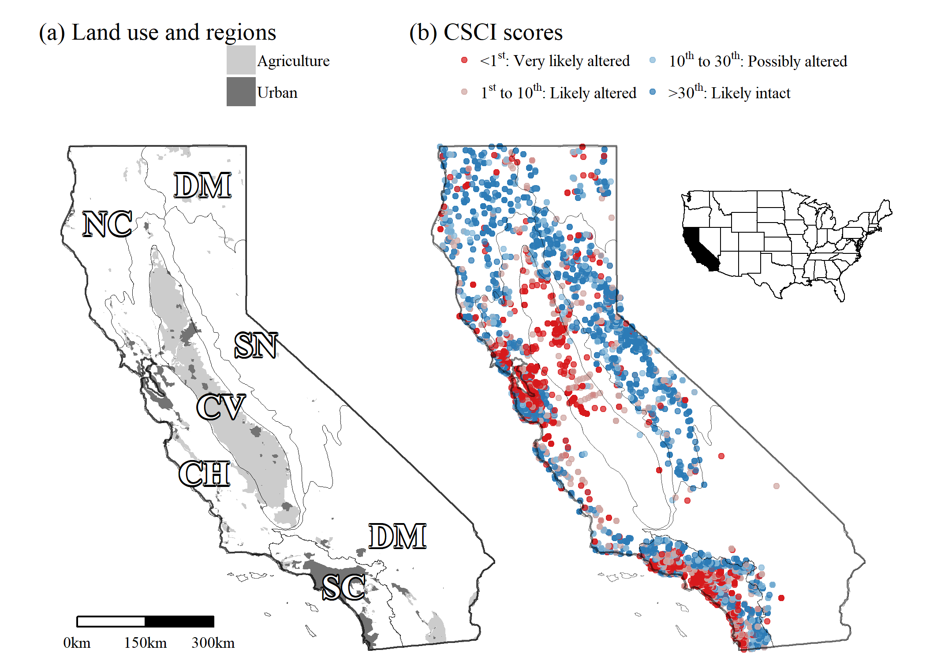

Figure 1 Urban and agricultural land use (a) and distribution of observed stream CSCI scores (b) in California. Cover of urban and agricultural land use in stream watersheds was used to develop a landscape model for stream segment expectations of bioassessment scores. Breakpoints for CSCI scores are the 1st, 10th, and 30th percentile of scores at least-disturbed, reference sites throughout the state. Altered and intact refers to biological condition (Mazor et al. 2016). Grey lines are major environmental regions in California defined by ecoregional and watershed boundaries, CV: Central Valley, CH: Chaparral, DM: Deserts and Modoc Plateau, NC: North Coast, SN: Sierra Nevada, SC: South Coast.

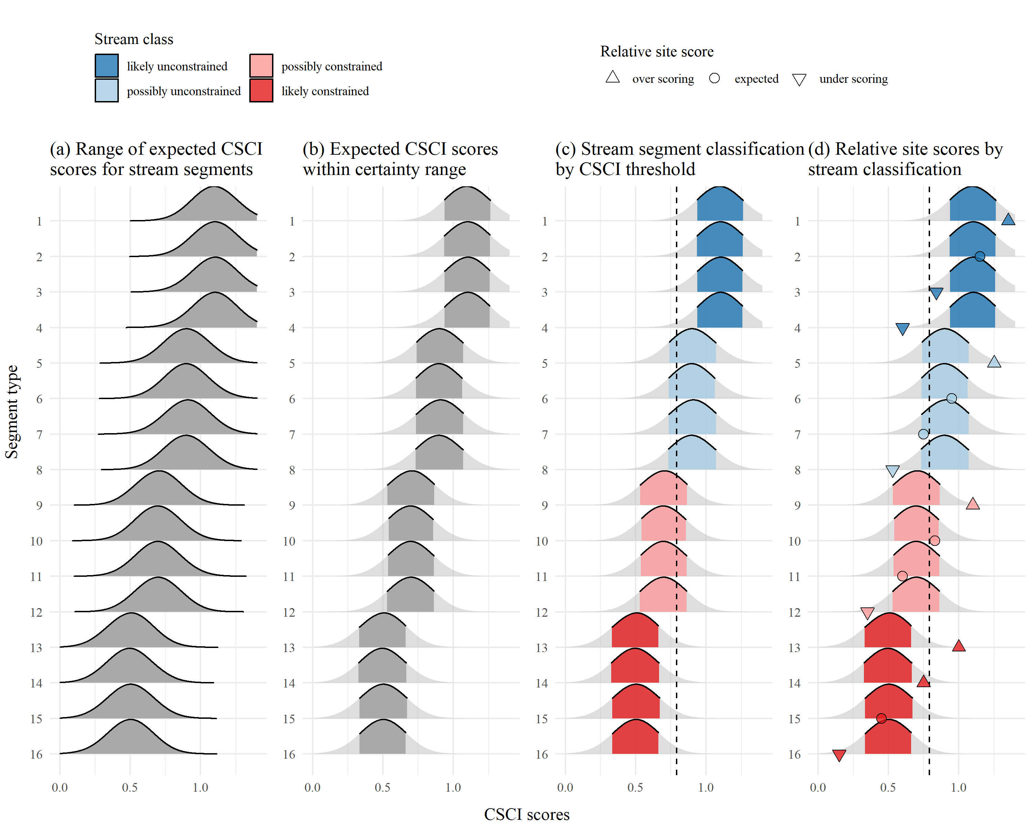

Figure 2 Application of the landscape model to identify site expectations and bioassessment performance for sixteen example stream segments. A range of CSCI scores is predicted from the model (a) and the lower and upper limits of the expectations are cut to define a certainty range for the predictions (b). Overlap of the certainty range at each segment with a chosen CSCI threshold (c) defines the stream segment classification as likely unconstrained, possibly unconstrained, possibly constrained, and likely constrained. The observed bioassessment scores are described relative to the classification as over scoring (above the certainty threshold), expected (within), and under scoring (below) for each of four stream classes (d).

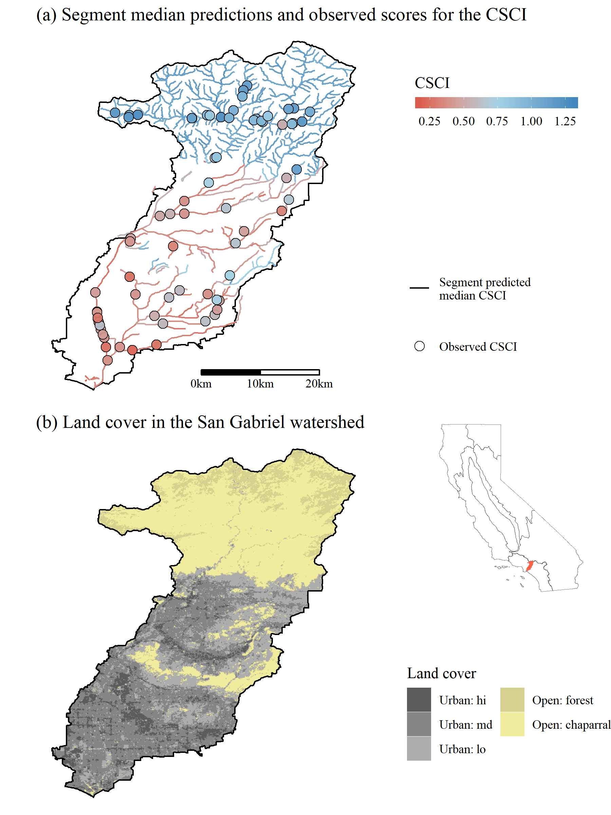

Figure 3 San Gabriel River watershed in southern California. Land cover is shown in plot (a) and the predicted median CSCI scores at each stream segment and observed CSCI scores are shown in (b).

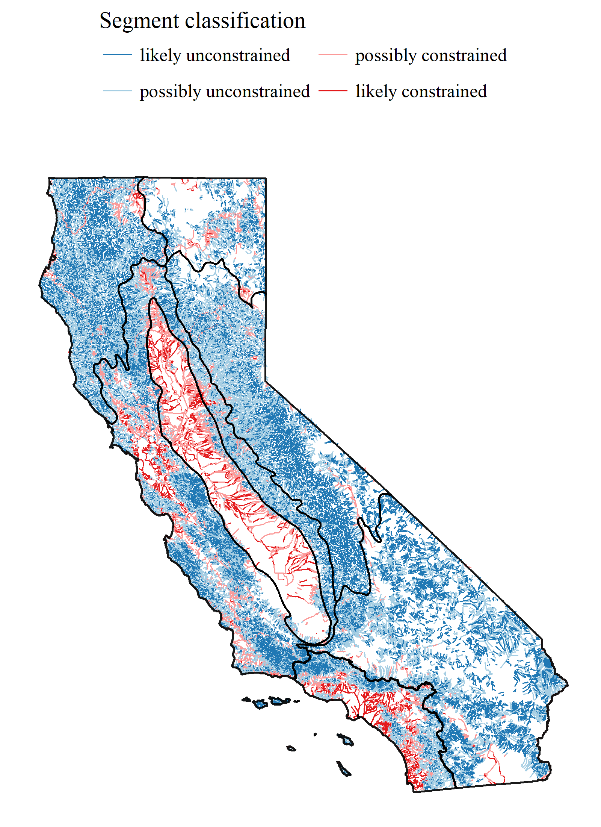

Figure 4 Statewide application of the landscape model showing the stream segment classifications. Major regional boundaries are also shown (see Figure 1).

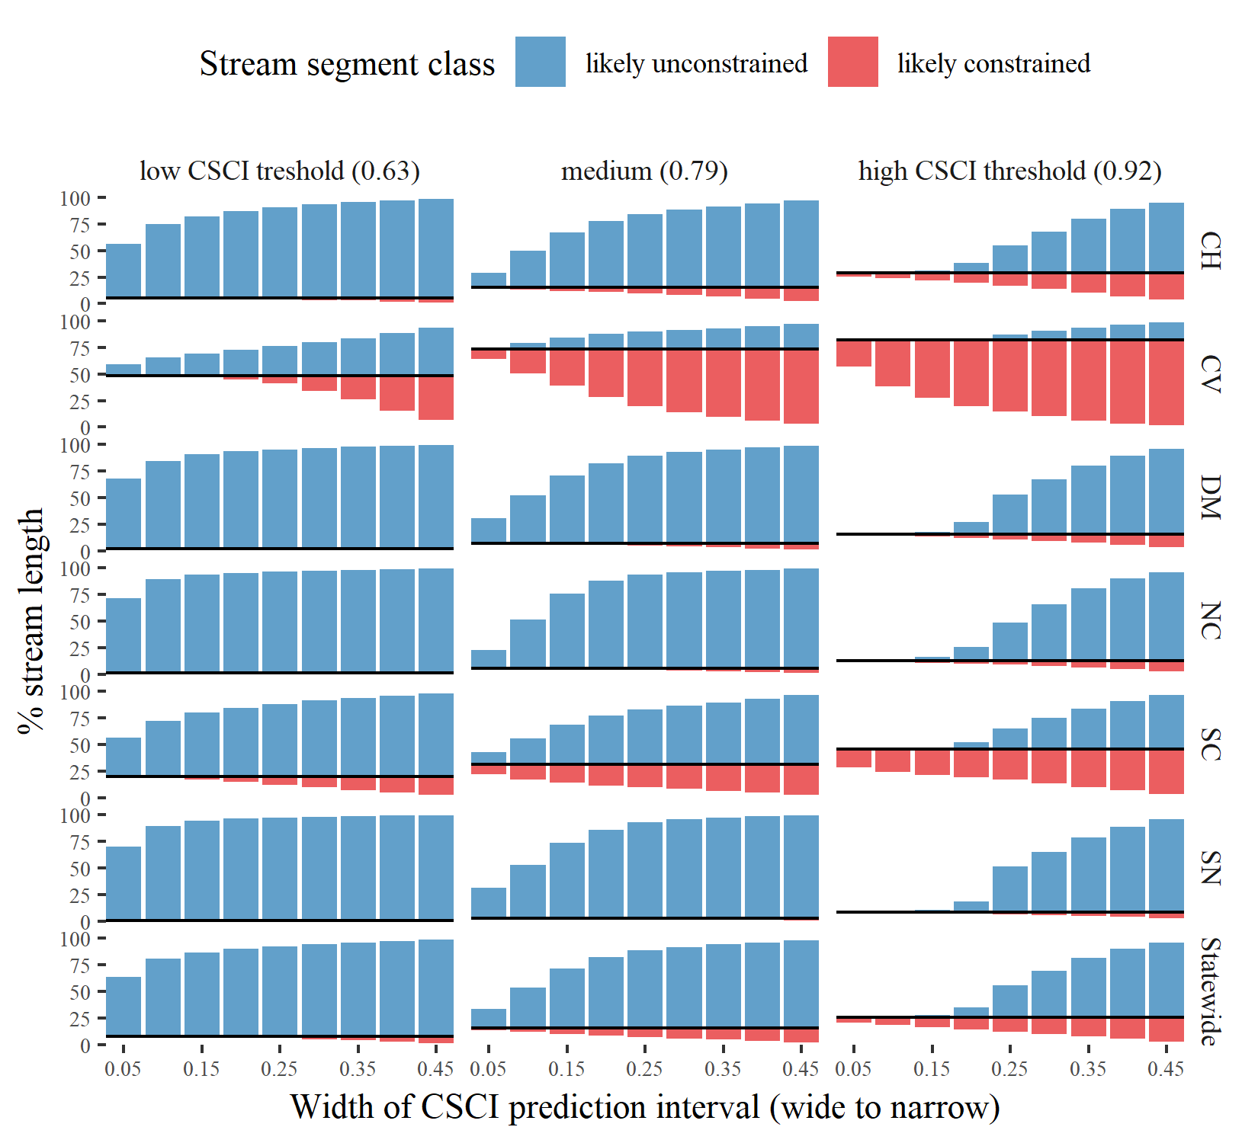

Figure 5 Changes in stream segment classes by region and statewide for different scenarios used to define biological constraints. Twenty-seven scenarios were tested that evaluated different combinations of certainty in the CSCI predictions (nine scenarios from wide to narrow prediction intervals as identified by the tail cutoff for the expected range) and potential CSCI thresholds (three scenarios from low to high). The percentage of total stream length for likely unconstrained and likely constrained is shown for each scenario. Stream classifications as possibly unconstrained or possibly constrained are not shown but can be inferred form the area of white space above or below each bar. The solid black line indicates the percentage division between unconstrained and constrained classifications. CV: Central Valley, CH: Chaparral, DM: Deserts and Modoc Plateau, NC: North Coast, SN: Sierra Nevada, SC: South Coast.

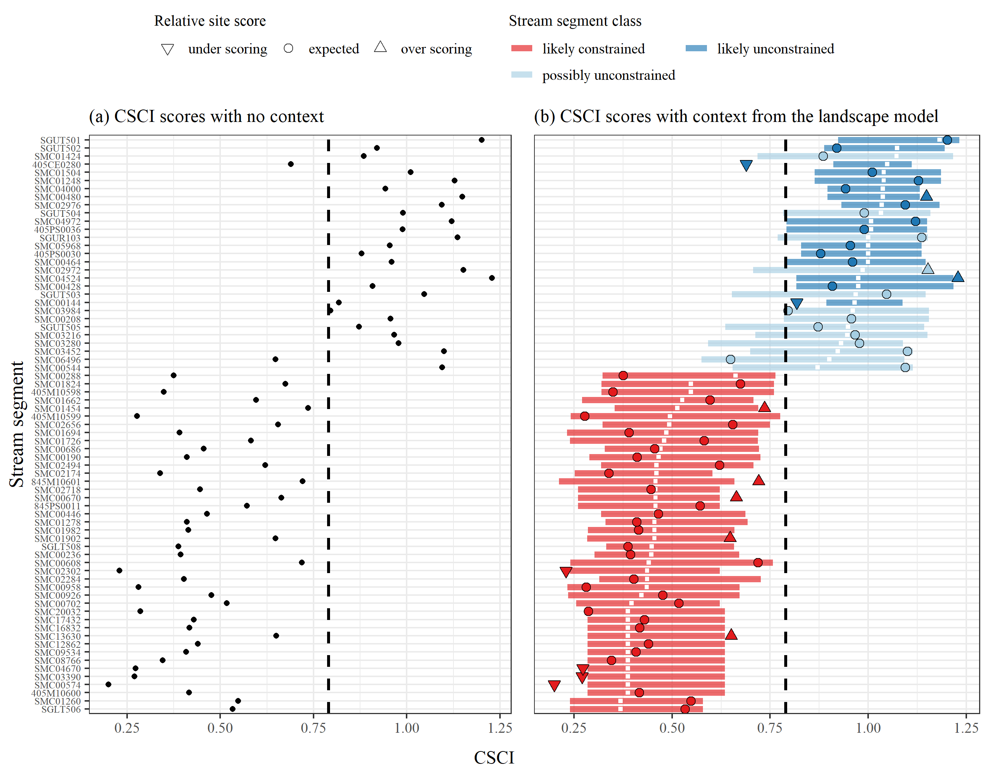

Figure 6 Application of the landscape model to stream segments in the San Gabriel River watershed, Los Angeles County, California. CSCI scores with (a) no context from the model are on the left and (b) scores with context from the model are on the right. Relative site scores as under-scoring, expected, or over-scoring are based on observed scores given the segment class as likely constrained, possibly constrained, possibly unconstrained, and likely unconstrained. Segment classes are based on overlap of the expectations with a biological threshold for the CSCI (0.79, dashed lined) and location of the median expectation (white ticks).

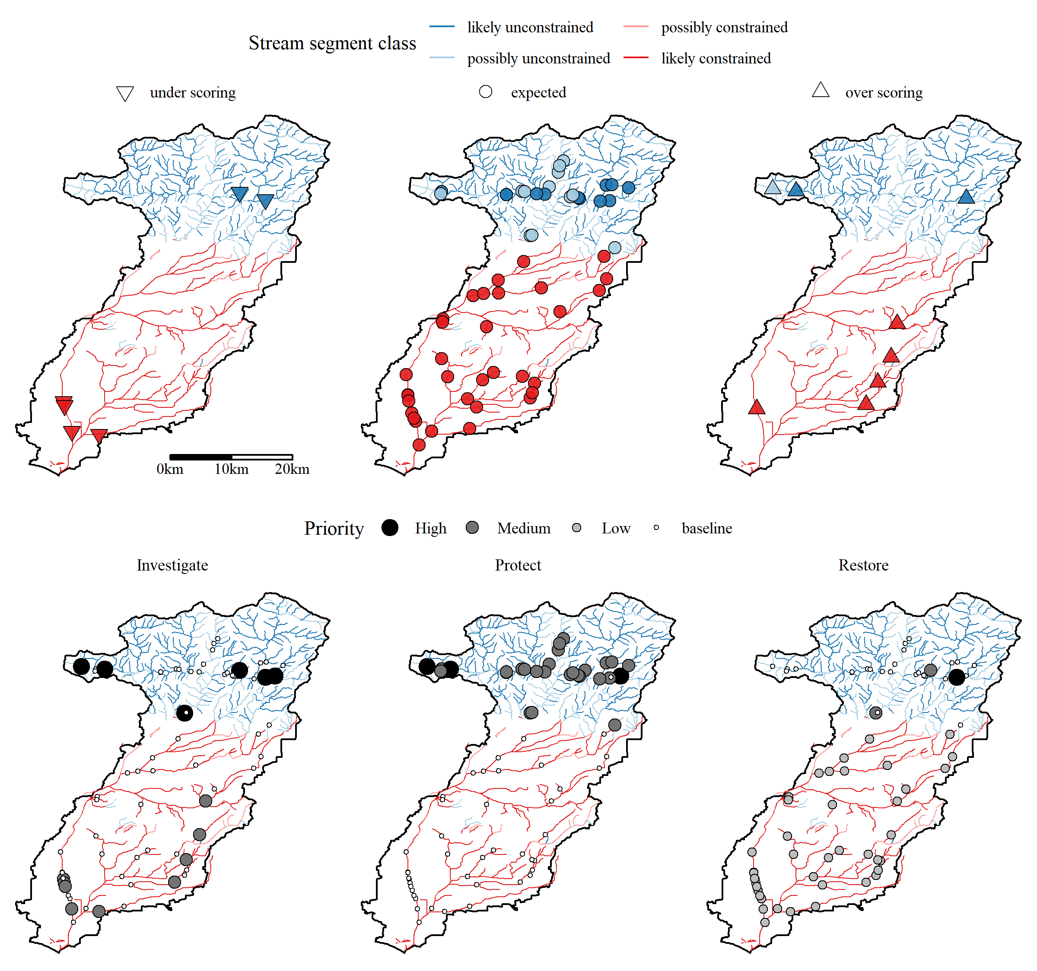

Figure 7 Relative site scores and recommended management actions for locations with CSCI scores in the San Gabriel River watershed. Relative site scores as under scoring, expected, or over scoring are based on observed scores given the segment class as likely constrained, possibly constrained, possibly unconstrained, and likely unconstrained. Recommended management actions were defined by a local stakeholder group (see Figure S1) and are ranked by priority for actions to investigate, protect, and restore a site. No recommended actions assume baseline maintenance and monitoring is sufficient.

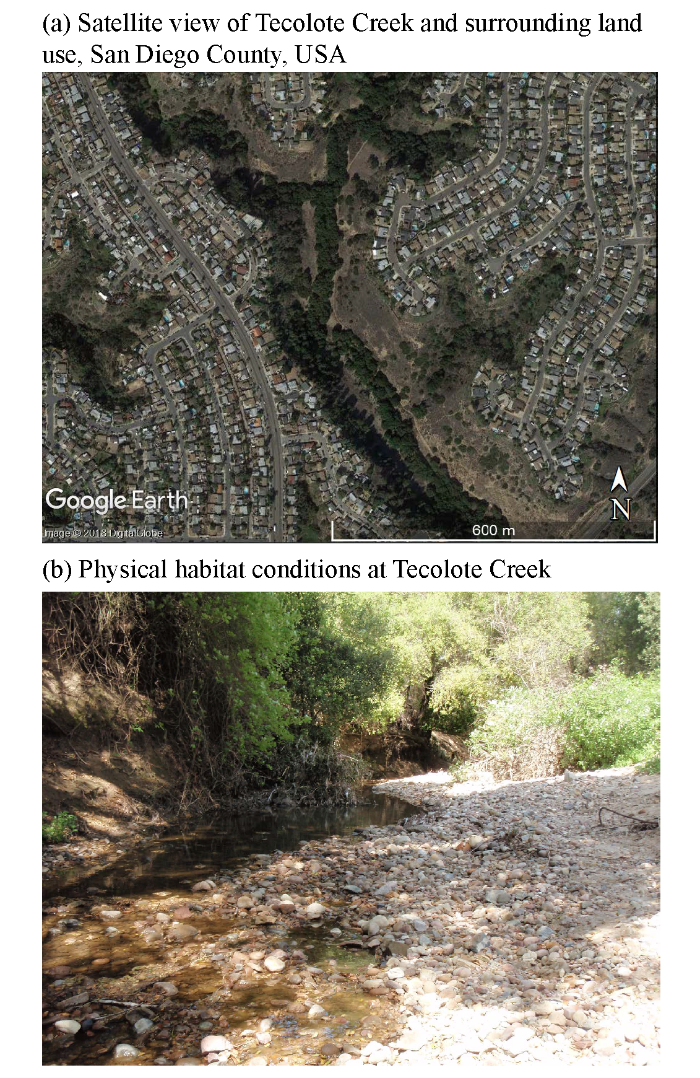

Figure 8 Tecolote Creek (San Diego County, USA) is a constrained channel in an urban landscape (a, Source: 32.81736, -117.19986. Google Earth. November 8, 2016. Accessed July 20, 2018.). Physical habitat (b, Source: R. Mazor) at the sample site suggests no channel alteration. The CSCI was scored at 0.61 indicating degraded biological integrity.

# Tables

Table 1 Land use variables used to develop the landscape model of stream bioassessment scores. All variables were obtained from StreamCat (Hill et al. 2016) and applied to stream segments in the National Hydrography Dataset Plus (NHD-plus) (McKay et al. 2012). The measurement scales for each variable are at the riparian (100 m buffer), catchment, and/or watershed, scale relative to a stream segment. Combined scales for riparian measurements (e.g., riparian + catchment, riparian + watershed) are riparian estimates for the entire catchment or watershed area upstream, as compared to only the individual segment. Total urban and agriculture land use variables were based on sums of individual variables in StreamCat as noted in the description. Rp100: riparian, Cat: catchment, Ws: watershed

|  |  |  |  |
| --- | --- | --- | --- |
| Name | Scale | Description | Unit |
| CanalDens | Cat, Ws | Density of NHDPlus line features classified as canal, ditch, or pipeline | km/sq km |
| PctImp2006 | Cat, Ws, Cat + Rp100, Ws + Rp100 | Mean imperviousness of anthropogenic surfaces (NLCD 2006) | % |
| TotUrb2011 | Cat, Ws, Cat + Rp100, Ws + Rp100 | Total urban land use as sum of developed open, low, medium, and high intensity (NLCD 2011) | % |
| TotAg2011 | Cat, Ws, Cat + Rp100, Ws + Rp100 | Total agricultural land use as sum of hay and crops (NLCD 2011) | % |
| RdDens | Cat, Ws, Cat + Rp100, Ws + Rp100 | Density of roads (2010 Census Tiger Lines) | km/sq km |
| RdCrs | Cat, Ws | Density of roads-stream intersections (2010 Census Tiger Lines-NHD stream lines) | crossings/sq km |

Table 2 Stream class definitions describing potential biological constraints. Classes are based on the overlap of the range of likely bioassessment scores with a potential threshold for a biological objective. Identifying stream classes requires selecting the cutoff range of likely scores from the landscape model and a chosen threshold for the objective.

|  |  |  |
| --- | --- | --- |
| Class | Definition | Example |
| Likely unconstrained | Lower bound of prediction interval is above threshold | 10th percentile > 0.79 |
| Possibly unconstrained | Lower bound of prediction interval is below threshold, but median prediction is above | 50th percentile > 0.79 |
| Possibly constrained | Upper bound of prediction interval is above threshold, but median prediction is below | 50th percentile < 0.79 |
| Likely constrained | Upper bound of prediction interval is below threshold | 90th percentile < 0.79 |

Table 3 Performance of the landscape model by calibration (Cal) and validation (Val) datasets in predicting CSCI scores. The statewide dataset (Figure 4) and individual regions of California (Figure 1) are evaluated. Averages and standard deviations (in parentheses) for observed and predicted CSCI values of each dataset are shown. Pearson correlations (r), root mean squared errors (RMSE), intercept, and slopes are for comparisons of predicted and observed values to evaluate model performance. All correlations, intercepts, and slopes are significant at alpha = 0.05. CV: Central Valley, CH: Chaparral, DM: Deserts and Modoc Plateau, NC: North Coast, SN: Sierra Nevada, SC: South Coast.

|  |  |  |  |  |  |  |  |  |
| --- | --- | --- | --- | --- | --- | --- | --- | --- |
| Dataset | Location | n | Observed | Predicted | r | RMSE | Intercept | Slope |
| Cal | Statewide | 1965 | 0.82 (0.26) | 0.83 (0.20) | 0.75 | 0.17 | 0.34 | 0.60 |
|  | CH | 512 | 0.76 (0.27) | 0.79 (0.21) | 0.71 | 0.19 | 0.38 | 0.54 |
|  | CV | 116 | 0.51 (0.18) | 0.57 (0.15) | 0.66 | 0.15 | 0.29 | 0.54 |
|  | DM | 86 | 0.87 (0.22) | 0.91 (0.14) | 0.50 | 0.20 | 0.63 | 0.31 |
|  | NC | 208 | 0.92 (0.20) | 0.94 (0.13) | 0.55 | 0.17 | 0.61 | 0.36 |
|  | SC | 631 | 0.79 (0.24) | 0.78 (0.21) | 0.75 | 0.16 | 0.27 | 0.65 |
|  | SN | 412 | 0.98 (0.18) | 0.98 (0.09) | 0.45 | 0.16 | 0.75 | 0.23 |
| Val | Statewide | 655 | 0.82 (0.25) | 0.84 (0.20) | 0.72 | 0.18 | 0.36 | 0.58 |
|  | CH | 172 | 0.76 (0.27) | 0.81 (0.21) | 0.74 | 0.19 | 0.39 | 0.56 |
|  | CV | 40 | 0.52 (0.19) | 0.59 (0.16) | 0.49 | 0.19 | 0.38 | 0.40 |
|  | DM | 28 | 0.84 (0.17) | 0.93 (0.11) | 0.55 | 0.17 | 0.63 | 0.36 |
|  | NC | 71 | 0.94 (0.19) | 0.96 (0.11) | 0.55 | 0.16 | 0.67 | 0.31 |
|  | SC | 208 | 0.80 (0.24) | 0.78 (0.21) | 0.72 | 0.17 | 0.27 | 0.63 |
|  | SN | 136 | 0.97 (0.17) | 0.98 (0.09) | 0.21 | 0.17 | 0.88 | 0.11 |

*Table 4: (#tab:clstot) Summary of stream length for each stream class statewide and major regions of California (Figures 1, 4). Lengths are in kilometers with the percentage of the total length in a region in parentheses. All lengths are based on a CSCI threshold of 0.79 and the 10th to 90th percentile of expected scores from the landscape model. CV: Central Valley, CH: Chaparral, DM: Deserts and Modoc Plateau, NC: North Coast, SN: Sierra Nevada, SC: South Coast.*

|  | constrained | | unconstrained | |
| --- | --- | --- | --- | --- |
| Region | likely | possibly | possibly | likely |
| Statewide | 8150 (4) | 24735 (11) | 101591 (46) | 85317 (39) |
| CV | 3356 (22) | 8010 (52) | 3202 (21) | 951 (6) |
| CH | 1642 (3) | 7840 (13) | 30693 (50) | 21206 (35) |
| DM | 255 (0) | 3395 (6) | 27194 (47) | 26479 (46) |
| NC | 108 (0) | 1442 (5) | 14152 (49) | 13286 (46) |
| SN | 20 (0) | 1067 (3) | 18228 (48) | 19032 (50) |
| SC | 2770 (15) | 2981 (16) | 8122 (45) | 4363 (24) |

*Table 5: (#tab:reltot) Summary of CSCI scores by relative expectations for each stream class statewide and in each major region of California (Figures 1, 4). Average CSCI scores (standard deviation) and counts (percent) of the number of monitoring stations in each relative score category and region are shown. Sites are over-scoring if the observed scores are above the range of expectations at a segment, expected if within the range, or under-scoring if below the range. CV: Central Valley, CH: Chaparral, DM: Deserts and Modoc Plateau, NC: North Coast, SN: Sierra Nevada, SC: South Coast.*

|  | under-scoring | | expected | | over-scoring | |
| --- | --- | --- | --- | --- | --- | --- |
| Region | CSCI | n (%) | CSCI | n (%) | CSCI | n (%) |
| Statewide | 0.54 (0.21) | 267 (10) | 0.83 (0.23) | 2041 (80) | 1.08 (0.17) | 242 (9) |
| CH | 0.47 (0.18) | 89 (13) | 0.79 (0.24) | 535 (80) | 1.08 (0.17) | 45 (7) |
| CV | 0.34 (0.12) | 25 (17) | 0.54 (0.17) | 118 (81) | 0.63 (0.25) | 2 (1) |
| DM | 0.6 (0.17) | 15 (14) | 0.9 (0.17) | 89 (80) | 1.15 (0.08) | 7 (6) |
| NC | 0.66 (0.17) | 28 (10) | 0.93 (0.16) | 228 (82) | 1.15 (0.08) | 22 (8) |
| SC | 0.54 (0.22) | 56 (7) | 0.78 (0.22) | 656 (81) | 1.02 (0.2) | 97 (12) |
| SN | 0.67 (0.16) | 54 (10) | 0.99 (0.11) | 415 (77) | 1.16 (0.06) | 69 (13) |

# References

Allan, D., D. Erickson, and J. Fay. 1997. “The Influence of Catchment Land Use on Stream Integrity Across Multiple Spatial Scales.” *Freshwater Biology* 37 (1):149–61. <https://doi.org/10.1046/j.1365-2427.1997.d01-546.x>.

Allan, J. D. 2004. “Landscapes and Riverscapes: The Influence of Land Use on Stream Ecosystems.” *Annual Review of Ecology, Evolution, and Systematics* 35:257–64. <https://doi.org/10.1146/annurev.ecolsys.35.120202.110122>.

Bailey, R. C., T. B. Reynoldson, A. G. Yates, J. Bailey, and S. Linke. 2007. “Integrating Stream Bioassessment and Landscape Ecology as a Tool for Land Use Planning.” *Freshwater Biology* 52 (5):908–17. <https://doi.org/10.1111/j.1365-2427.2006.01685.x>.

Beck, M. W. 2018. “SCCWRP/SCAPE: v1.0 (Version 1.0). Zenodo, <http://doi.org/10.5281/zenodo.1218121>.”

Beechie, T., G. Pess, P. Roni, and G. Giannico. 2007. “Setting River Restoration Priorities: A Review of Approaches and General Protocol for Identifying and Prioritizing Actions.” *North American Journal of Fisheries Management* 28 (3):891–905. <https://doi.org/10.1577/M06-174.1>.

Board, San Diego Regional Water Quality Control. 2016. “Clean Water Act Sections 305(B) and 303(D) Integrated Report for the San Diego Region.” Sacramento, California: California Environmental Protection Agency. <https://www.waterboards.ca.gov/sandiego/water_issues/programs/303d_list/docs/Staff_Report_101216.pdf>.

Breiman, L. 2001. “Random Forests.” *Machine Learning* 45:5–32.

Brody, S. D. 2003. “Measuring the Effects of Stakeholder Participation on the Quality of Local Plans Based on the Principles of Collaborative Ecosystem Management.” *Journal of Planning Education and Research* 22 (4):407–19. <https://doi.org/10.1177/0739456X03022004007>.

Brown, L. R., T. F. Cuffney, J. F. Coles, F. Fitzpatrick, G. McMahon, J. Steuer, A. H. Bell, and J. T. May. 2009. “Urban Streams Across the USA: Lessons Learned from Studies in Nine Metropolitan Areas.” *Journal of the North American Benthological Society* 28 (4):1051–69. <https://doi.org/10.1899/08-153.1>.

Brown, L. R., J. T. May, A. C. Rehn, P. R. Ode, I. R. Waite, and J. G. Kennen. 2012. “Predicting Biological Condition in Southern California Streams.” *Landscape and Urban Planning* 108 (1):17–27. <https://doi.org/10.1016/j.landurbplan.2012.07.009>.

Buss, D. F., D. M. Carlisle, T. -S. Chon, J. Culp, J. s. Harding, H. E. Keizer-Vlek, W. A. Robinson, S. Strachan, C. Thirion, and R. M. Hughes. 2014. “Stream Biomonitoring Using Macroinvertebrates Around the Globe: A Comparison of Large-Scale Programs.” *Environmental Monitoring and Assessment* 187:4132. <https://doi.org/10.1007/s10661-014-4132-8>.

Cade, B. S., and B. R. Noon. 2003. “A Gentle Introduction to Quantile Regression for Ecologists.” *Frontiers in Ecology and the Environment* 1 (8):412–20.

California Regional Water Quality Control Board, Los Angeles Region. 2014. “Basin Plan for the Coastal Watersheds of Los Angeles and Ventura Counties.”

Cao, Y., C. P. Hawkins, J. Olson, and M. A. Kosterman. 2007. “Modeling Natural Environmental Gradients Improves the Accuracy and Precision of Diatom-Based Indicators.” *Journal of the North American Benthological Society* 26 (3):566–85. <https://doi.org/10.1899/06-078.1>.

Carline, R. F., and M. C. Walsh. 2007. “Responses to Riparian Restoration in the Spring Creek Watershed, Central Pennsylvania.” *Restoration Ecology* 15 (4):731–42. <https://doi.org/10.1111/j.1526-100X.2007.00285.x>.

Carlisle, D. M., J. Falcone, and M. R. Meador. 2009. “Predicting the Biological Condition of Streams: Use of Geospatial Indicators of Natural and Anthropogenic Characteristics of Watersheds.” *Environmental Monitoring and Assessment* 151 (1-4):143–60. <https://doi.org/10.1007/s10661-008-0256-z>.

Chen, K., R. M. Hughes, S. Xu, J. Zhang, D. Cai, and B. Wang. 2014. “Evaluating Performance of Macroinvertebrate-Based Adjusted and Unadjusted Multi-Metric Indices (MMI) Using Multi-Season and Multi-Year Samples.” *Ecological Indicators* 36:142–51. <https://doi.org/10.1016/j.ecolind.2013.07.006>.

Chessman, B. C. 2014. “Predicting Reference Assemblages for Freshwater Bioassessment with Limiting Environmental Difference Analysis.” *Freshwater Science* 33 (4):1261–71. <https://doi.org/10.1086/678701>.

Chessman, B. C., M. Muschal, and M. J. Royal. 2008. “Comparing Apples with Apples: Use of Limiting Environmental Differences to Match Reference and Stressor-Exposure Sites for Bioassessment of Streams.” *River Research and Applications* 24 (1):103–17. <https://doi.org/10.1002/rra.1053>.

Chessman, B. C., and M. J. Royal. 2004. “Bioassessment Without Reference Sites: Use of Environmental Filters to Predict Natural Assemblages of River Macroinvertebrates.” *Journal of the North American Benthological Society* 23 (3):599–615. <https://doi.org/10.1899/0887-3593(2004)023%3C0599:BWRSUO%3E2.0.CO;2>.

Clapcott, J. E., K. J. Collier, R. G. Death, E. O. Goodwin, J. S. Harding, D. Kelly, J. R. Leathwick, and R. G. Young. 2011. “Quantifying Relationships Between Land-Use Gradients and Structural and Functional Indicators of Stream Ecological Integrity.” *Freshwater Biology* 57 (1):74–90. <https://doi.org/10.1111/j.1365-2427.2011.02696.x>.

Cormier, S. M., G. W. Suter II, L. Zhang, and G. J. Pond. 2013. “Assessing Causation of the Extirpation of Stream Macroinvertebrates by a Mixture of Ions.” *Environmental Toxicology and Chemistry* 32 (2):277–87. <https://doi.org/10.1002/etc.2059>.

Davies, S. P., and S. K. Jackson. 2006. “The Biological Condition Gradient: A Descriptive Model for Interpreting Change in Aquatic Ecosystems.” *Ecological Applications* 16 (4):1251–66.

Domisch, S., G. Amatulli, and W. Jetz. 2015. “Near-Global Freshwater-Specific Environmental Variables for Biodiversity Analyses in 1 Km Resolution.” *Scientific Data* 2:150073. <https://doi.org/10.1038/sdata.2015.73>.

ESRI (Environmental Systems Research Institute). 2016. “ArcGIS v10.5.”

Finkenbine, J. K., J. W. Atwater, and D. S. Mavinic. 2000. “Stream Health After Urbanization.” *Journal of the American Water Resources Association* 36 (5):1149–60. <https://doi.org/10.1111/j.1752-1688.2000.tb05717.x>.

Florida Department of Environmental Protection. 2011. “Development of aquatic life use support attainment thresholds for Florida’s Stream Condition Index and Lake Vegetation Index.” DEP-SAS-003/11. Tallahassee, Florida: FDEP Standards; Assessment Section, Bureau of Assessment; Restoration Support.

Fox, E. W., R. A. Hill, S. G. Leibowitz, A. R. Olsen, D. J. Thornbrugh, and M. H. Weber. 2017. “Assessing the Accuracy and Stability of Variable Selection Methods for Random Forest Modeling in Ecology.” *Environmental Monitoring and Assessment* 189:316. <https://doi.org/10.1007/s10661-017-6025-0>.

Fry, J., G. Xian, S. Jin, J. Dewitz, C. Homer, L. Yang, C. Barnes, N. Herold, and J. Wickham. 2011. “Completion of the 2006 National Land Cover Database for the Conterminous United States.” *Photogrammetric Engineering and Remote Sensing* 77 (9):858–64.

Hastie, T., R. Tibshirani, and J. Friedman. 2009. *The Elements of Statistical Learning: Data Mining, Inference, and Prediction*. 2nd ed. New York: Springer.

Hill, R. A., E. W. Fox, S. G. Leibowitz, A. R. Olsen, D. J. Thornbrugh, and M. H. Weber. 2017. “Predictive Mapping of the Biotic Condition of Conterminous U.S. Rivers and Streams.” *Ecological Applications* 27 (8):2397–2415. <https://doi.org/10.1002/eap.1617>.

Hill, R. A., M. H. Weber, S. G. Leibowitz, A. R. Olsen, and D. J. Thornbrugh. 2016. “The Stream-Catchment (StreamCat) Dataset: A Database of Watershed Metrics for the Conterminous United States.” *Journal of the American Water Resources Assocation* 52:120–28. <https://doi.org/10.1111/1752-1688.12372>.

Howard, J. K., K. A. Fesenmyer, T. E Grantham, J. H. Viers, P. R. Ode, P. B. Moyle, S. J. Kupferburg, et al. 2018. “A Freshwater Conservation Blueprint for California: Prioritizing Watersheds for Freshwater Biodiversity.” *Freshwater Science* 37 (2):417–31. <https://doi.org/10.1086/697996>.

Howard, J. K., K. R. Klausmeyer, K. A. Fesenmyer, J. Furnish, T. Gardali, T. Grantham, J. V. E. Katz, et al. 2015. “Patterns of Freshwater Species Richness, Endemism, and Vulnerability in California.” *PLOS ONE* 10 (7):e0130710. <https://doi.org/10.1371/journal.pone.0130710>.

Howard, J., and C. Revenga. 2000. “California’s Freshwater Biodiversity in a Continental Context. Science for Conservation Technical Brief Series.” San Francisco, CA: The Nature Conservancy of California.

Kenney, M. A., P. R. Wilcock, B. F. Hobbs, N. E. Flores, and D. C. Martínez. 2012. “Is Urban Stream Restoration Worth It?” *Journal of the American Water Resources Association* 48 (3):603–15. <https://doi.org/10.1111/j.1752-1688.2011.00635.x>.

Leps, M., J. D. Tonkin, V. Dahm, P. Haase, and A. Sundermann. 2015. “Disentangling Environmental Drivers of Benthic Invertebrate Assemblages: The Role of Spatial Scale and Riverscape Heterogeneity in a Multiple Stressor Environment.” *Science of the Total Environment* 536:546–56. <https://doi.org/10.1016/j.scitotenv.2015.07.083>.

Lester, R. E., and A. J. Boulton. 2008. “Rehabilitating Agricultural Streams in Australia with Wood: A Review.” *Environmental Management* 42 (2):310–26. <https://doi.org/10.1007%2Fs00267-008-9151-1>.

Loflen, C., H. Hettesheimer, L. B. Busse, K. Watanabe, R. M. Gersberg, and V. Lüderitz. 2016. “Inadequate Monitoring and Inappropriate Project Goals: A Case Study on the Determination of Success for the Forester Creek Improvement Project.” *Ecological Restoration* 34 (2):124–34. <https://doi.org/10.3368/er.34.2.124>.

Mazor, R. D., M. W. Beck, and J. Brown. 2018. “2017 Report on the SMC Regional Stream Survey.” 1029. Costa Mesa, California: Southern California Coastal Water Research Project.

Mazor, R. D., A. C. Rehn, P. R. Ode, M. Engeln, K. C. Schiff, E. D. Stein, D. J. Gillett, D. B. Herbst, and C. P. Hawkins. 2016. “Bioassessment in Complex Environments: Designing an Index for Consistent Meaning in Different Settings.” *Freshwater Science* 35 (1):249–71.

McKay, L., T. Bondelid, T. Dewald, J. Johnston, R. Moore, and A. Reah. 2012. “NHDPlus Version 2: User Guide.”

Meinshausen, N. 2006. “Quantile Regression Forests.” *Journal of Machine Learning Research* 7:983–99.

Meinshausen, Nicolai. 2017. *QuantregForest: Quantile Regression Forests*. <https://CRAN.R-project.org/package=quantregForest>.

Midwest Biodiversity Institute. 2016. “Identification of predictive habitat attributes for Minnesota streams to support tiered aquatic life uses.” MBI Technical Report MBI/OHPAN1518840. Columbus, Ohio: Midwest Biodiversity Institute, prepared on behalf of the Minnesota Pollution Control Agency.

Morgan, R. P., and S. E. Cushman. 2005. “Urbanization Effects on Stream Fish Assemblages in Maryland, USA.” *Journal of the North American Benthological Society* 24 (3):643–55.

Moss, D., M. T. Furse, J. F. Wright, and P. D. Armitage. 1987. “The Prediction of the Macro-Invertebrate Fauna of Unpolluted Running-Water Sites in Great Britain Using Environmental Data.” *Freshwater Biology* 17 (1):41–52. <https://doi.org/10.1111/j.1365-2427.1987.tb01027.x>.

Nel, J. L., D. J. Roux, R. Abell, P. J. Ashton, R. M. Cowling, J. V. Higgins, M. Thieme, and J. H. Viers. 2009. “Progress and Challenges in Freshwater Conversation Planning.” *Aquatic Conservation: Marine and Freshwater Ecosystems* 19 (4):474–85. <https://doi.org/10.1002/aqc.1010>.

Novotny, V., A. Bartosová, N. O’Reilly, and T. Ehlinger. 2005. “Unlocking the Relationship of Biotic Integrity of Impaired Waters to Anthropogenic Stresses.” *Water Research* 39 (1):184–98. <https://doi.org/10.1016/j.watres.2004.09.002>.

Ode, P. R., A. C. Rehn, R. D. Mazor, K. C. Schiff, E. D. Stein, J. T. May, L. R. Brown, et al. 2016. “Evaluating the Adequacy of a Reference-Site Pool for Ecological Assessments in Environmentally Complex Regions.” *Freshwater Science* 35 (1):237–48.

Paul, M. J., D. W. Bressler, A. H. Purcell, M. T. Barbour, E. T. Rankin, and V. H. Resh. 2008. “Assessment Tools for Urban Catchments: Defining Observable Biological Potential.” *Journal of the American Water Resources Association* 45 (2):320–30. <https://doi.org/10.1111/j.1752-1688.2008.00280.x>.

Quinn, J. M., and A. E. Wright-Stow. 2008. “Stream Size Influences Stream Temperature Impacts and Recovery Rates After Clearfell Logging.” *Forest Ecology and Management* 256 (12):2101–9. <https://doi.org/10.1016/j.foreco.2008.07.041>.

RDCT (R Development Core Team). 2018. “R: A language and environment for statistical computing, v3.4.4. R Foundation for Statistical Computing, Vienna, Austria.”

Reed, M. S. 2008. “Stakeholder Participation for Environmental Management: A Literature Review.” *Biological Conservation* 141 (10):2417–31. <https://doi.org/10.1016/j.biocon.2008.07.014>.

Rehn, A. C., R. D. Mazor, and P. R. Ode. 2018. “An Index to Measure the Quality of Physical Habitat in California Wadeable Streams.” SWAMP Technical Memorandum, SWAMP-TM-2018-0005. Sacramento, California: California Water Boards, Surface Water Ambient Monitoring Program, California Department of Fish; Wildlife, Southern California Coastal Water Research Project. <https://www.waterboards.ca.gov/water_issues/programs/swamp/bioassessment/docs/physical_habitat_index_technical_memo.pdf>.

Reynoldson, T. B., R. H. Norris, V. H. Resh, K. E. Day, and D. M. Rosenberg. 1997. “The Reference Condition: A Comparison of Multimetric and Multivariate Approaches to Assess Water-Quality Impairment Using Benthic Macroinvertebrates.” *Journal of the North American Benthological Society* 16 (4):833–52.

Riseng, C. M., M. J. Wiley, R. W. Black, and M. D. Munn. 2011. “Impacts of Agricultural Land Use on Biological Integirty: A Causal Analysis.” *Ecological Applications* 21 (8):3128–46. <https://doi.org/10.1890/11-0077.1>.

Roni, P., and T. Beechi. 2012. *Stream and Watershed Restoration Guide: A Guide to Restoring Riverine Processes and Habitats*. First. Hoboken, New Jersey: John Wiley & Sons.

San Diego Regional Water Quality Control Board. 2001. “Waste discharge requirements for discharges of urban runoff from the municipal separate storm sewer systems (MS4s) draining the watersheds of the County of San Diego, the incorporated cities of San Diego County, and the San Diego unified port district.”

Shoredits, A. S., and J. A. Clayton. 2013. “Assessing the Practice and Challenges of Stream Restoration in Urbanized Environments of the USA.” *Geography Compass* 7 (5):358–72. <https://doi.org/10.1111/gec3.12039>.

Sleeter, B. M., T. S. Wilson, C. E. Soulard, and J. Liu. 2011. “Estimation of the Late Twentieth Century Land-Cover Change in California.” *Environmental Monitoring and Assessment* 173 (1-4):251–66. <https://doi.org/10.1007/s10661-010-1385-8>.

Sponseller, R. A., E. F. Benfield, and H. M. Valett. 2001. “Relationships Between Land Use, Spatial Scale and Stream Macroinvertebrate Communities.” *Freshwater Biology* 46 (10):1409–24. <https://doi.org/10.1046/j.1365-2427.2001.00758.x>.

Stein, E. D., M. R. Cover, A. E. Fetscher, C. O’Reilly, R. Guardado, and C. W. Solek. 2013. “Reach-Scale Geomorphic and Biological Effects of Localized Streambank Armoring.” *Journal of the American Water Resources Association* 49 (4):780–92. <https://doi.org/10.1111/jawr.12035>.

Stein, E. D., A. Sengupta, R. D. Mazor, K. McCune, B. P. Bledsoe, and S. Adams. 2017. “Application of Regional Flow-Ecology Relationships to Inform Watershed Management Decisions: Applications of the ELOHA Framework in the San Diego River Watershed, California, USA.” *Ecohydrology* 10 (7):e1869. <https://doi.org/10.1002/eco.1869>.

Stoddard, J. L., D. P. Larsen, C. P. Hawkins, R. K. Johnson, and R. H. Norris. 2006. “Setting Expectations for the Ecological Condition of Streams: The Concept of Reference Condition.” *Ecological Applications* 16 (4):1267–76.

Stone, M. K., and J. B. Wallace. 1998. “Long-Term Recovery of a Mountain Stream from Clear-Cut Logging: The Effects of Forest Succession on Benthic Invertebrate Community Structure.” *Freshwater Biology* 39 (1):151–69. <https://doi.org/10.1046/j.1365-2427.1998.00272.x>.

Townsend, C. R., S. S. Uhlmann, and C. D. Matthaei. 2008. “Individual and Combined Responses of Stream Ecosystems to Multiple Stressors.” *Journal of Applied Ecology* 45 (6):1810–9. <https://doi.org/10.1111/j.1365-2664.2008.01548.x>.

US Environmental Protection Agency, Region 10. 2013. “Technical Support Docuemnt for EPA’s Action on the State of Oregon’s Revised Water Quality Standards for the West Division Main Canal.”

USEPA (US Environmental Protection Agency). 2016. “National Rivers and Streams Assessment 2008-2009: A Collaborative Survey.” EPA-841-R-16-007. Washington, DC.

USGS (US Geological Survey). 1999. “The quality of our nation’s waters: nutrients and pesticides.” Reston, Virginia.

Vølstad, J. H., N. E. Roth, G. Mercurio, M. T. Southerland, and D. E. Strebel. 2004. “Using Environmental Stressor Information to Predict the Ecological Status of Maryland Non-Tidal Streams as Measured by Biological Indicators.” *Environmental Monitoring and Assessment* 84 (3):219–42. <https://doi.org/10.1023/A:1023374524254>.

Waite, I. R. 2013. “Development and Application of an Agricultural Intensity Index to Intevertebreate and Algal Metrics from Streams at Two Scales.” *Journal of the American Water Resources Assocation* 49 (2):431–48. <https://doi.org/10.1111/jawr.12032>.

Waite, I. R., J. G. Kennen, J. T. May, L. R. Brown, T. F. Cuffney, K. A. Jones, and J. L. Orlando. 2014. “Stream Macroinvertebrate Response Models for Bioassessment Metrics: Addressing the Issue of Spatial Scale.” *PLOS ONE* 9 (3):e90944. <https://doi.org/10.1371/journal.pone.0090944>.

Walsh, C. J., A. H. Roy, J. w. Feminella, P. D. Cottingham, P. M. Groffman, and R. P. Morgan. 2005. “The Urban Stream Syndrome: Current Knowledge and the Search for a Cure.” *Journal of the North American Benthological Society* 24 (3):706–23. <https://doi.org/10.1899/04-028.1>.

Wang, L., J. Lyons, P. Kanehl, and R. Gatti. 1997. “Influences of Watershed Land Use on Habitat Quality and Biotic Integrity in Wisconsin Streams.” *Fisheries* 22 (6):6–12. <https://doi.org/10.1577/1548-8446(1997)022%3C0006:IOWLUO%3E2.0.CO;2>.